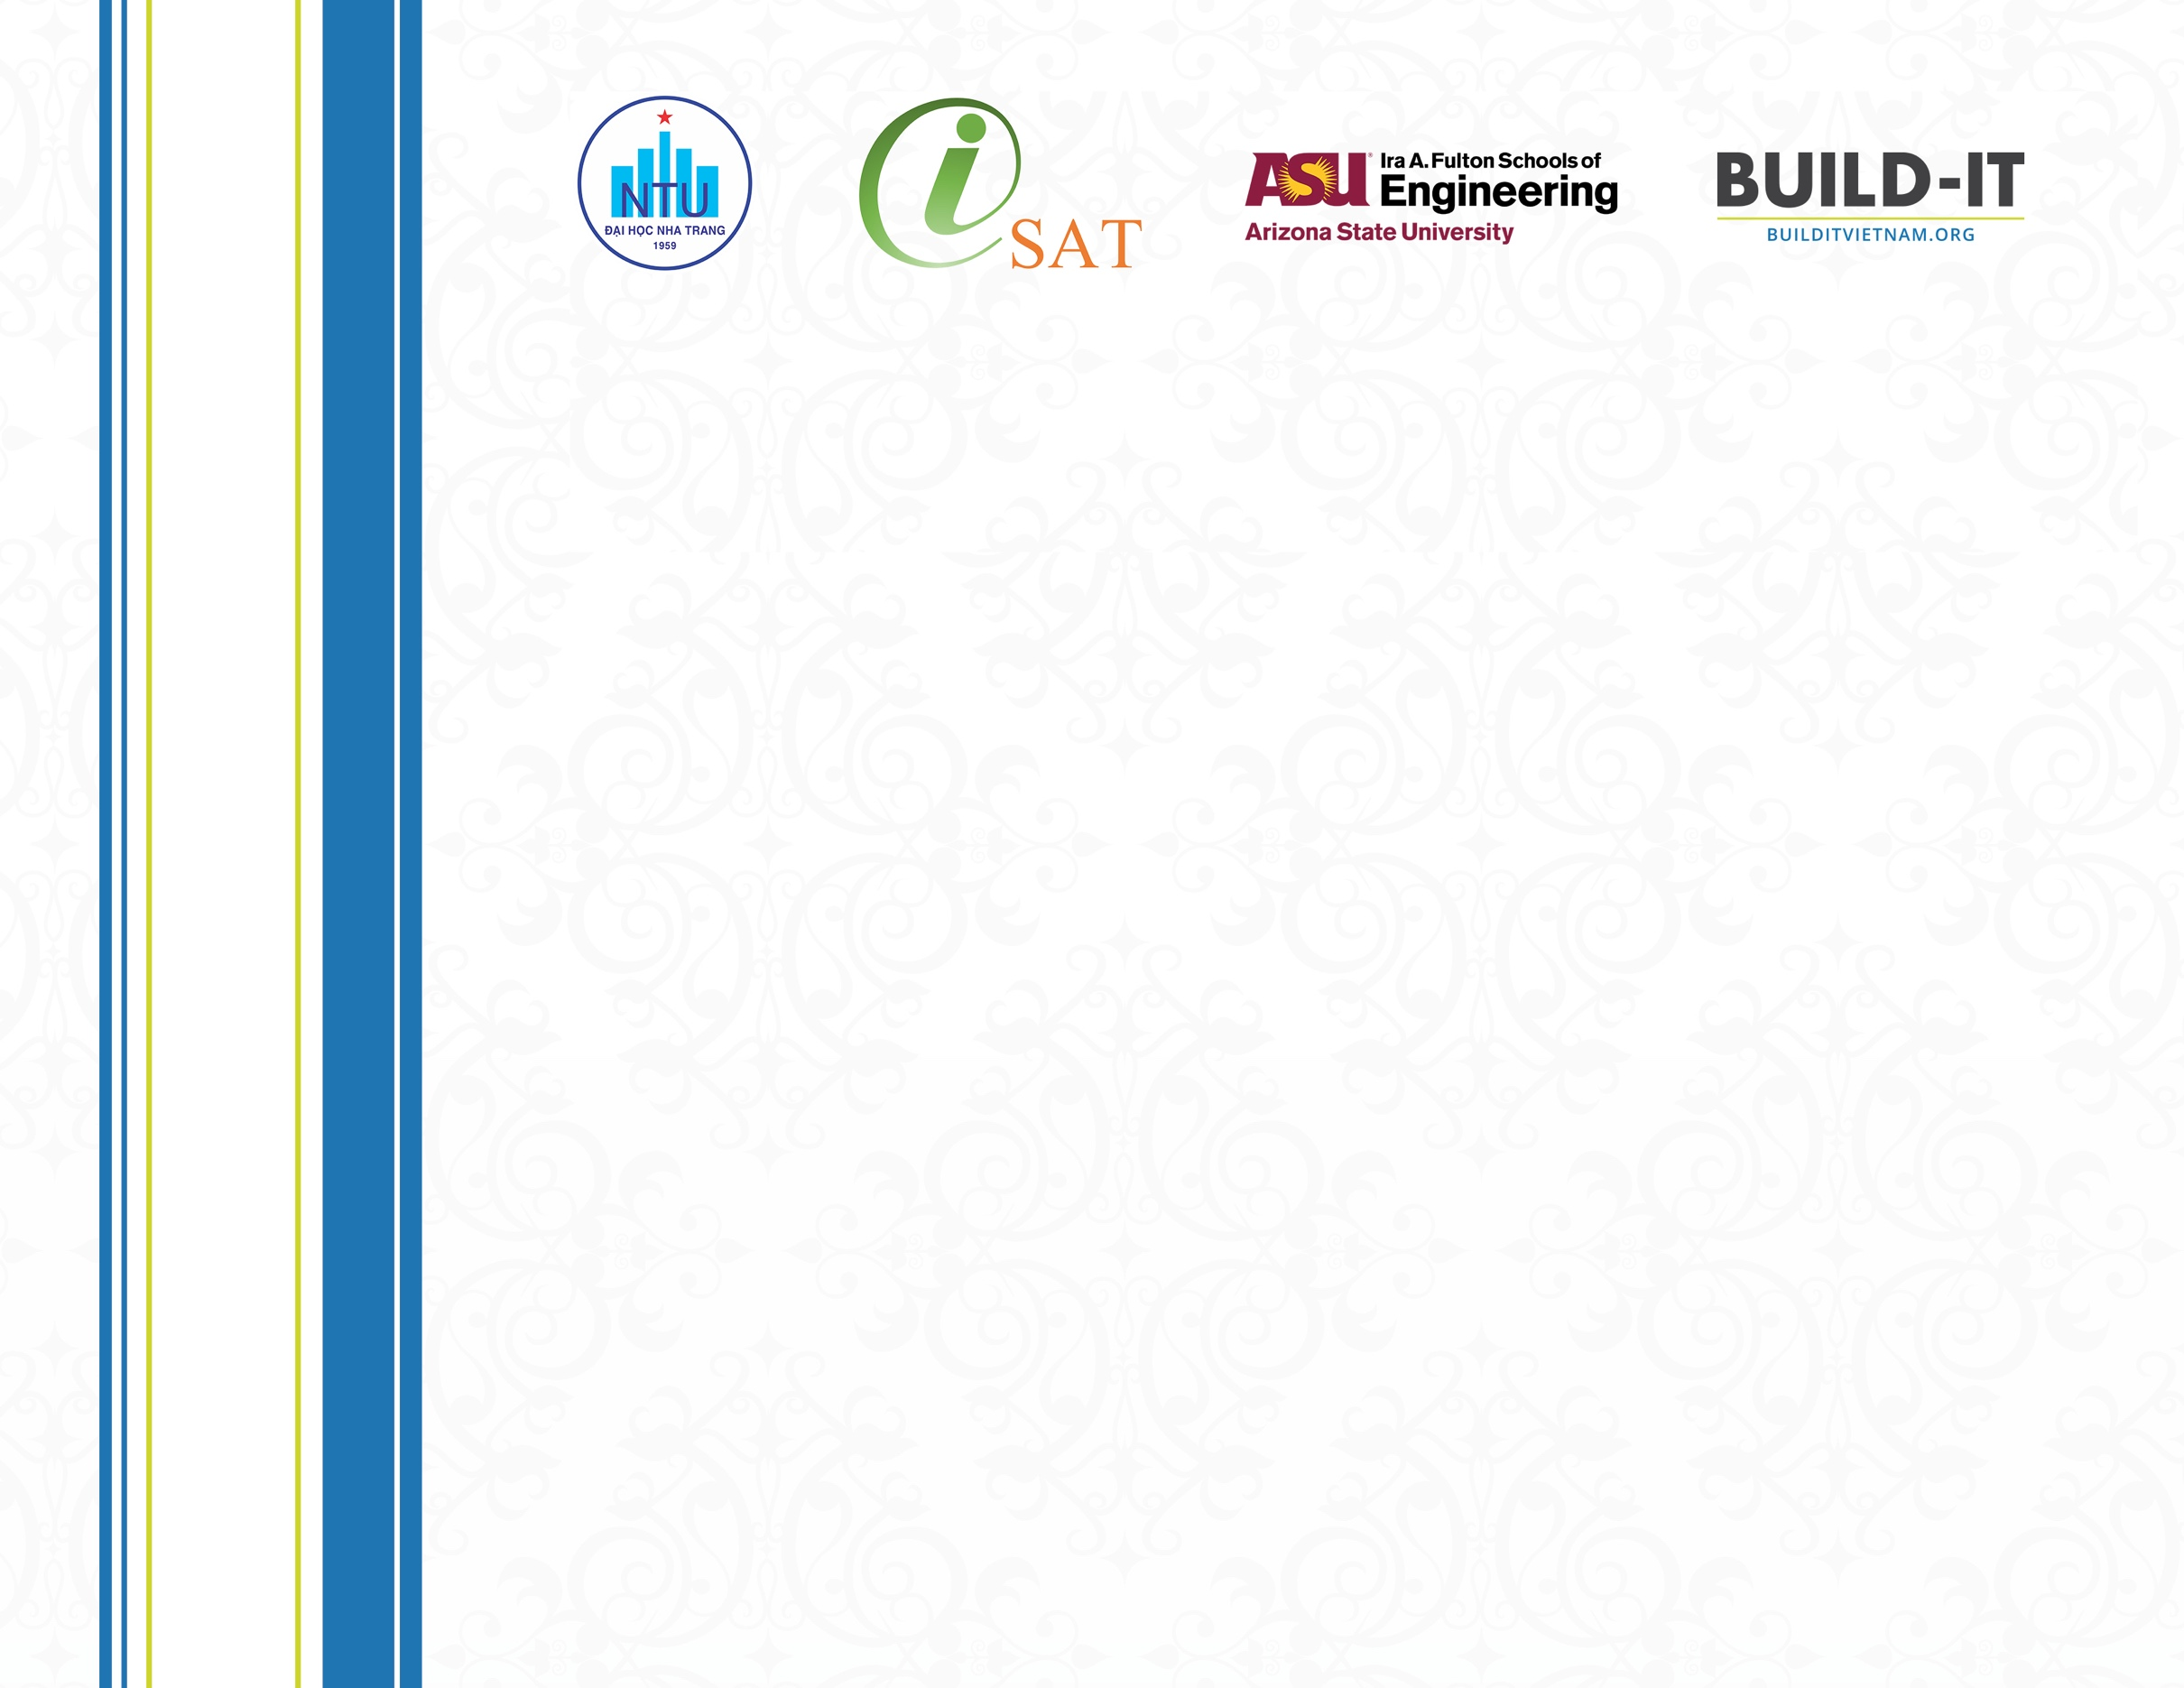



  - Tran Xuan Hai
Director
Institute of Science and Technology Innovation
  - Dr. Kathy Wigal
  - BUILD-IT Project Director
  - Associate Director for Curricular Innovation
  - Arizona State University

  - Jeffrey S. Goss
  - BUILD-IT Principal Investigator
  - Associate Vice Provost for Southeast Asia Programs
  - Arizona State University

  - Trang Sĩ Trung
  - Associate Professor
  - Rector of Nha Trang University

«Title» «FirstName» «LastName»
Nha Trang University, Arizona State University and Institute of Science and Technology Innovation present this certificate to

Certificate

Of Achievement
For their outstanding contribution in participating in the

«ConferenceName»
«Date» • «Location»

